

### PIRENS INSTITUTE OF BUSINESS MANAGEMENT AND ADMINSTRATION (IBMA)

ROLL NO :MC021070

Project Title : **Simple address book simulator with basic features.**

Name of Student:**Prashant vaijnath Phad**

Class :MCA-I

**Abstract**

**To develop an efficient and secure interface between Student, teacher and college.**

**1.Title of Project: Student Feedback System**

**2.Abstract**

**This is a simple address book in which you can save and retrieve entries. Entries can have a large amount of information, including name, address, phone number,date of birth,sex and with a specified number of lines available for notes. You can add, delete or modify entries,print all records or indivual record.Advance Search Option.**

**Simple address book simulator with basic features project will contain following contents:**

**➢ Add Contact**

**➢ Edit Contact**

**➢ Delete Contact**

**➢ Sort By Name**

**➢ Sort By Zip**

**➢ Save Contact**

**This Simple address book simulator Project is basically perform CRUD Operation,**

# INTRODUCTION

1. **The software to be designed is a program that can be used to maintain an address book. An address book holds a collection of entries, each recording a person's first and last names, address, city, state, zip, and phone number.**
2. **It must be possible to add a new person to an address book, to edit existing information about a person (except the person's name), and to delete a person. It must be possible to sort the entries in the address book alphabetically by last name , or by ZIP code It must be possible to print out all the entries in the address book in "O/p" format.**
3. **It must be possible to create a new address book, to open a disk file containing an existing address book to close an address book, and to save an address book to a disk file, using standard New, Open, Close, Save and Save As ... File menu options. The program's File menu will also have a Quit option to allow closing all open address books and terminating the program.**
4. **The program will keep track of whether any changes have been made to an address book since it was last saved, and will offer the user the opportunity to save changes when an address book is closed either explicitly or as a result of choosing to create/open another or to quit the program.**
5. **The program will keep track of the file that the current address book was read from or most recently saved to, will display the file's name as the title of the main window, and will use that file when executing the Save option. When a New address book is initially created, its window will be titled "Untitled", and a Save operation will be converted to Save As ... - i.e. the user will be required to specify a file.**

## OBJECTIVES

**Objective**

• The main idea was to develop such a system for both the administration and the common man so that they can easily find the detail of any person efficiently .

• It is easy to construct, operate and can easily be customized as per the requirement.

• The main aim objective of this application is to automate the complete

Operation of the address book.

They need maintain hundred of records.Also searching should be very faster so they can find requireddetails instantly.

* **Address Book**
* **UML Diagrams**
* **Person Database**
* **SQL Queries**
* **GUI Application**

## MODULES

To work correctly this application contains various module in it, and these modules are:

**New contact**: By use of this module a user can add the details of a new person in the application. The user can also add various information related to the person.

**Edit Contact:**

**Sort by Name :**

**Sort by Zip:**

**Save**: When the user will add a new contact to the system he/ she will have to save the information otherwise the information will get erased, However, The person will also save the information when he/she will edit the details.

**Delete**: This module will help the user to find any contact information just by entering contact person name.**What is Address Book Address Book is book or database used for storing entries called contacts Each contact entry usually consists of a few standard fields for eg name, address, phone no. etc The operations like adding, sorting, searching, deleting etc is done on the entries**

## IMPLIMENTATION TECHNIQUES

SOFTWARE REQUIREMENTS

Operating system : Windows7/8/10

Coding Language : Java, Jdbc ,

Data Base : Mysql :

IDE : Eclips ,Visual studio 2019

## PROJECT WORKING

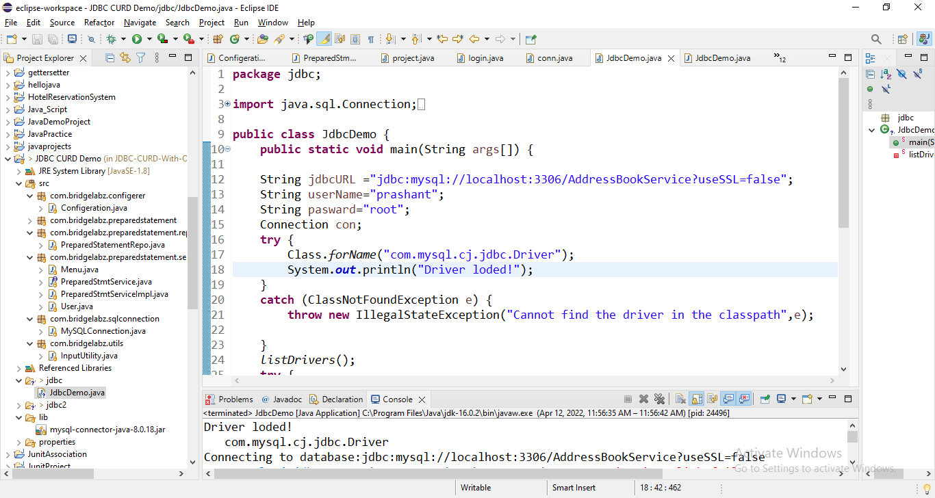



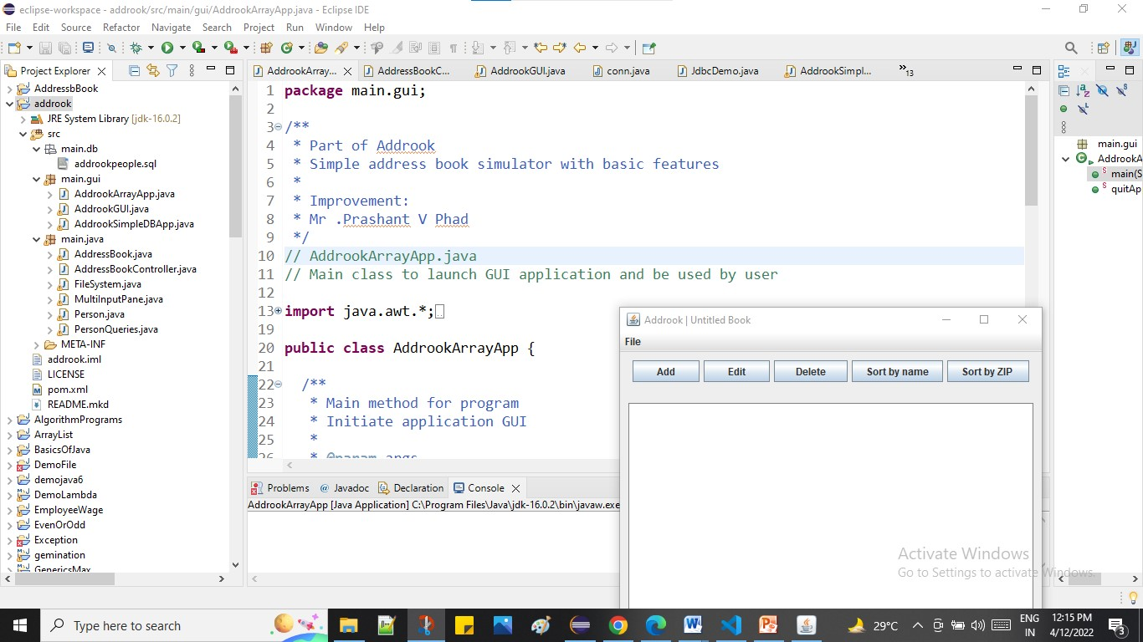

E-R Diagram

From Mysql_Workebanch

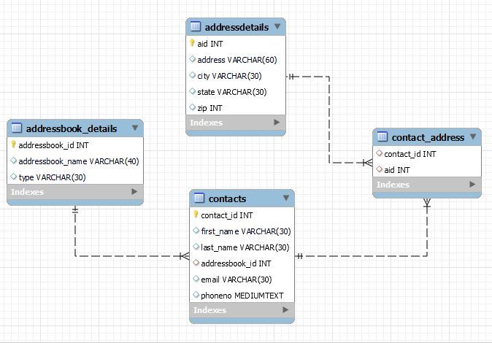

### Use Case Diagram

Admin

Book

Upda

Shopping cart

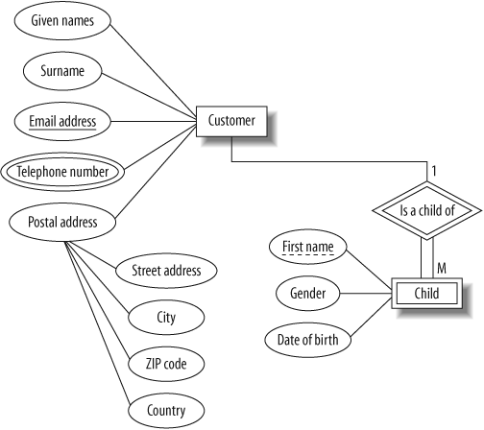



Deployment Diagram

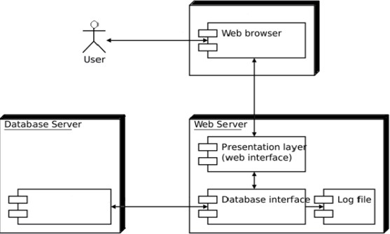

## RESULT

PAGEWISE PROJECT SCREENSHOT

1)

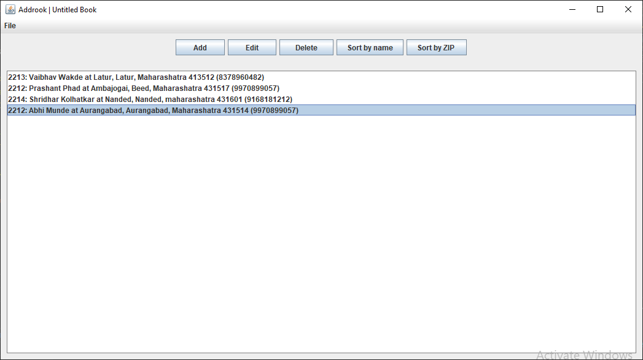

* Edit address

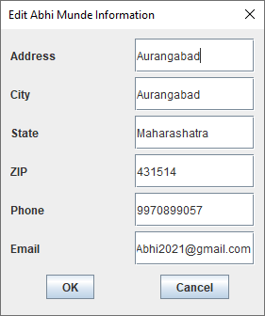

Delete

## C:\Users\AVENGER\Desktop\Mr Prashant\Screenshot 2022-04-11 095306.jpg

Edit

## 

## CONCLUSIONS

* **The simple database version is so simple, it just works to insert, browse, and find. It's only using one single database file and create addressbook.db automatically when it doesn't exists**.



**BIBLOGRAPHY**

Title: Addrook

Ver: 1.0

Desc: Simple address book simulator with basic features

Name: Mr.Prashant V Phad

IDE: Vs.code,Eclips

Docs: Java™ How to Program, Seventh Edition & OOAD_Example

Chap: 2 & 3. Software Engineering Case Study

Page: 63 - 522 & 1215 - *

Date: April_2022

## ANY QUESTIONS..?

THANK YOU..!